Revision of colours

Name:

- Read

 |  |  |  | 
white | yellow | orange | pink | red
 |  |  |  | 
violet | purple | blue | green | brown
 |  |  | 
 |  | black | grey
- Can you guess what colour I am? Write!
der -
lube -
genre -
ronwb -
htewi -
weylol -
kinp -
prelup -
3. Can you guess what colour it is? – Write!
What colour is the lizard? It’s .
What colour is the sun? It’s .
What colour is the sky? It’s .
What colour is an orange? It’s .
What colour is a lemon? It’s .
What colour is the bear? It’s .
What colour is red and blue mixed? It’s .
- Write! What colour is this?
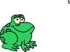The frog is The lion is
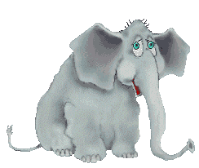 The elephant is The robot is
The fish is
The bird is
The butterfly is
The car is
- Print and then colour!
Try and wear a hat when the sun is shining. Your head must not get too hot.

